1. **Logical Circuits:**

A logical circuit is a combination of circuit components that are fed inputs of 2 preset voltages to represent the binary 0 and 1 used in Boolean logic to express a variable in a false/low state or a true/high state respectively. These components are the building blocks of all artificial-computational logic. These operations are like ordinary algebraic expressions in that they are [commutative](http://hyperphysics.phy-astr.gsu.edu/hbase/alg2.html#ap), [associative](http://hyperphysics.phy-astr.gsu.edu/hbase/alg2.html#ap), and [distributive](http://hyperphysics.phy-astr.gsu.edu/hbase/alg2.html#ap). There is a group of useful theorems of Boolean algebra that help in developing the logic for a given operation and a set of procedures used to simplify the expression of said operation. Most logical circuits are made of or can be simplified to contain three basic digital components (and, or, not) that preform a Boolean operation on their input variables. There are 16 total functions that result from their combination with only 2 Binary inputs and are shown in the table directly below taken from (The Hyper Physics Textbook).

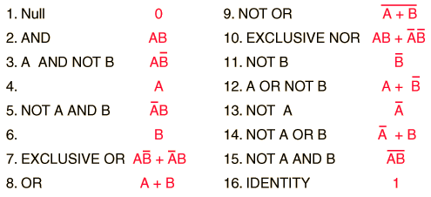

The applications of digital logic involve functions of the AND, OR, and NOT operations. These operations are subject to the following identities:

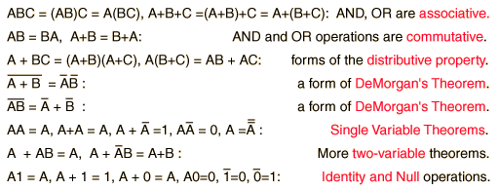

1. **Truth Tables:**

A truth table is a pectoral representation of how a logic circuit's output is determined by various combinations of the Boolean inputs, using logic 1 for true and logic 0 as false. All of the possible combinations of the inputs (2^(#input variables) possible combinations) are listed to the left, the output of the circuit is listed on the right. The output column can be achieved by a combination of logic [gates](http://hyperphysics.phy-astr.gsu.edu/hbase/electronic/gate.html#c1). An example of the truth table used to design our BCD display circuit is provided below with x’s representing do not care conditions which will be explained shortly.

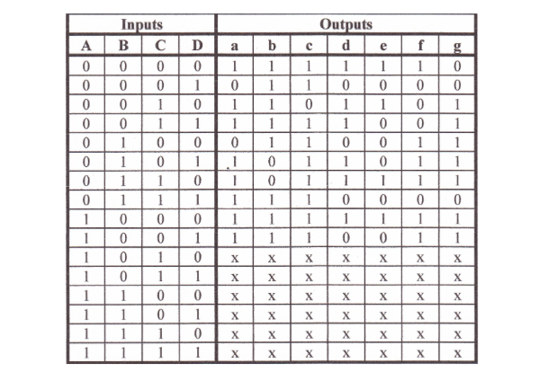

1. **K-maps:**

A Karnaugh map, like a truth table, is another pictorial representation of the output; produced by all combinations of input for a specific function. They are used to simplify Boolean functions by grouping together expressions with common factors and eliminating unwanted variables.

Below is a truth table with it’s corresponding K-map provided by the article “Logical Operators and Truth Tables”

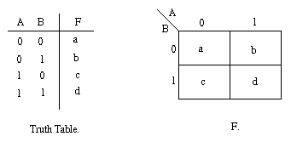

In this project we used K maps to produce simplified Boolean Functions from the provided truth table to activate each of the Display’s segments. Multiple functions and combination circuits were possible, that while not algebraically equivalent to each other, would produce all of the true outputs because of the do not care conditions specific to this assignment.

1. **Do Not Care Conditions:**

In certain cases, the designer of a circuit may intend for the circuit to never receive certain input combinations due to its function. The reason for this being, that the inputs have a specific meaning given the context of the circuits intended purpose. This means that, for the given application certain patterns of inputs may not have a defined meaning. So it is irrelevant what output the circuit would give for these input combinations. The output can be chosen to be whatever makes the circuit simplest. These input combinations are called ``don't-care'' conditions, because we don't care what the output would be. In K-maps do not care conditions are represented using an x rather than a 1 or 0 and can be grouped with either for circuit simplification.

1. **BCD – Seven Segment Display:**

Typically [7-segment displays](http://www.electronics-tutorials.ws/blog/7-segment-display-tutorial.html) consist of seven individual coloured LED’s (called the segments), within one single display package. In order to produce the required numbers of characters from 0 to 9 on the display the correct combination of LED segments need to be illuminated and BCD to 7-segment Display Decoders .A standard 7-segment LED display generally has 8 input connections, one for each LED segment and one that acts as a common terminal or connection for all the internal display segments.

